|  |
| --- |
| **Design Brief** |

**Project Title:**

Investigative Data Project

**Client:**

Noah Allen and Justin Harsono

**Designers:**

Arianna McDonald and Jeffrey Hsu

**Problem Statement:**

Preparing for the SAT has become more and more prevalent in high school. With SAT class prices steeply climbing into the thousands of dollars, many parents question if SAT scores even play that big of a role in their child’s future success. Forbes webpage even points out that parents will “often agonize over whether to pay for test prep classes or tutors, but ultimately many do spring for it; the tutoring and test prep industry makes billions of dollars a year. Often, when they do pay for it, they wonder if it’s worth it.” In other words, will paying for SAT classes be a cost-worthy investment toward increasing your chance at success. This is important to understand because it has the potential to either save you thousands of dollars, or to make an investment into the future that will pay off any money you might have spent on SAT preparatory classes.

**Design Statement:** (how to create our design)

When we encounter questions that are open to interpretations, we create both short and long term answers. The short term payoff is whether or not SAT prep will yield a good SAT score. This can be determined by looking at past students and their respective SAT scores to find a correlation between SAT prep classes and higher exam scores. A long-term payoff is determined instead by the lasting benefits of taking the classes. These benefits are manifests of success, however, there are various measures of success. Therefore, our research will take into account an individual’s opinion of whether their high SAT score got them what they wanted. Our style is very personal, we would look at each case individually to make sure we are collecting accurate data and using it for the intended purpose. Every case is different and we know that there are other variables to consider, so we tend to go in-depth in our research and discovery. We would hope to use this information to provide helpful information to both students and parents as well as administrators so they can evaluate the the cost vs. yield and determine if SAT prep is something worthwhile for their specific situations. As we are both students, we understand the importance of the SAT and it’s effect on our futures, and are well acquainted with the anxiety that comes with it. Because we have this understanding, it is guaranteed that we are passionate about this topic and want to complete the task to the best of our ability. As far as design goes, we’d like to do something that is both functional and tasteful, so that it gets the job done in style.

<https://nces.ed.gov/fastfacts/display.asp?id=171>

**Constraints:** (Constraints for the user)

* Time
* Money
* People
* Energy

Schifrin, M. (2014, August 12). Top 100 SAT Scores Ranking: Which Colleges Have The Brightest Kids? Retrieved February 02, 2017, from <http://www.forbes.com/sites/schifrin/2014/08/04/top-100-sat-scores-ranking-which-colleges-have-the-brightest-kids/#3730c77238a1>

How do SAT scores affect quality of life after college?

<http://blog.prepscholar.com/does-sat-predict-your-college-success-and-future-income>

<http://time.com/money/3732797/best-colleges-high-earnings/>

<http://blog.prepscholar.com/average-sat-scores-by-state-most-recent>

<http://www.forbes.com/sites/schifrin/2014/08/04/top-100-sat-scores-ranking-which-colleges-have-the-brightest-kids/#1133910038a1>

Analyzing the Correlation Between Taking SAT Prep Classes and the Rates of Improvement which Translates to whether Prep Classes are Beneficial or not.

Original Data

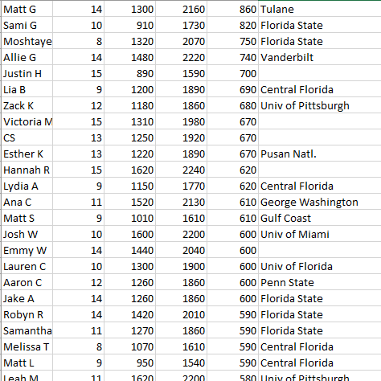

Percentage of Improvements of Students that took SAT Prep Classes

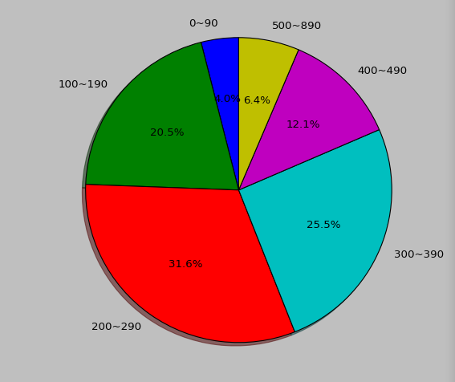

There seems to be a definite margin of improvement of students that took SAT Prep Classes. The majority of them experience a significant increase in their scores, thus justifying the legibility of the prep classes.